

|  |  |
| --- | --- |
|  | **UNIVERSITI TUNKU ABDUL RAHMAN** |
|  | **Lab 1** |
| Course Code: | UEMH3163/UECS2053/UECS2153 |
| Course Name: | Artificial Intelligence |
| Lecturer: | Dr. Ng Oon-Ee |
| Academic Session: | 2019/05 |
| Title: | Traveling Salesman Problem (TSP) |

|  |  |  |  |
| --- | --- | --- | --- |
| Name | I.D. No | Course | Practical Group |
| Tan Ying Yao | 1703648 | SE | P1 |
|  |  |  | Mark: /100 |

Result:

First, to get the list of cities to travel between. We used tsp-case04.txt which is a large dataset containing 14,051 coordinates. The best route is the one nearest to the initial distance.

The genetic algorithm is set to have a population size of 100, elite size of 10, mutation rate of 0.01% and a total of 500 iterations.

The initial distance is 41591202.32427467. After running for 27211.51580762863s, the best distance obtained through genetic algorithm is:

40911969.7015657

Plot:

The improvement can be seen in the graph below.

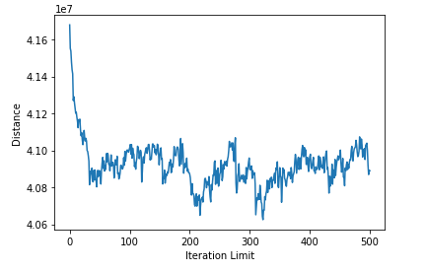

Conclusion:

The main question of the travelling salesman problem (TSP) is “Given a list of cities and the distances between each pair of cities, what is the shortest possible route that visits each city and returns to the origin city?”. The problem was first formulated in 1930 and is one of the most studied problem in terms of optimization. It can be used as a benchmark for many optimization methods.

Although the problem is computationally difficult, a large number of heuristics and exact algorithms are known, so tens of thousands of cities can be solved with million of cities and be approximated within a small fraction of 1%.

Genetic algorithm is a powerful, robust optimization search technique able to converge over successive generations toward a near global optimum via selection, crossover, and mutation operations. It then combines direction (selection and crossover) and chance (mutation) elements into a single effective and efficient search. Thus, Genetic algorithm are used to find good solutions in reasonable time.